

Technion – Israel Institute of Technology

Computer Science Faculty

Final Project Paper

Forecasting the wave-power in the Mediterranean Sea

By: Shilo Yair, Jonatan Merling

Supervisor: Assaf Schuster

Spring 2018

Table of contents

# Table of Figures                                                                                                    3

Resources 4-5

Abstract                                                                                                                 6

Introduction                                                                                                           6

Background                                                                                                          7-8

Formulas                                                                                                              8-10

Methods                                                                                                             10-11

Results                                                                                                                11-16

Conclusion                                                                                                            16

Appendix                                                                                                            17-20

Bibliography                                                                                                      21-22

# Table of Figures

Figure 1- visual explanation about the wave properties. [5](https://docs.google.com/document/d/1iU2hUuLJWr2-5zLBvXPs_xezGo0FHD2b7YJZecs2OYA/edit#heading=h.1t3h5sf)

Figure 2-example of interpolation of Significant wave height(VHM0)

along the Mediterranean Sea7

[Figure 3 -](https://docs.google.com/document/d/1iU2hUuLJWr2-5zLBvXPs_xezGo0FHD2b7YJZecs2OYA/edit#heading=h.17dp8vu) example of the values of Significant wave height(VHM0)

over time at a specific point7

Figure 4 -prediction at 28.9.18 for 2.10.189

Figure 5 - presents the interpolation of the wave-power values in 2.10.18 10

[Figure 6 -](https://docs.google.com/document/d/1iU2hUuLJWr2-5zLBvXPs_xezGo0FHD2b7YJZecs2OYA/edit#heading=h.z337ya)  example of high values in Greece area 10

[Figure 7 -](https://docs.google.com/document/d/1iU2hUuLJWr2-5zLBvXPs_xezGo0FHD2b7YJZecs2OYA/edit#heading=h.1y810tw)  example of low values in most eastern region of the Mediterranean 11

[Figure 8 -](https://docs.google.com/document/d/1iU2hUuLJWr2-5zLBvXPs_xezGo0FHD2b7YJZecs2OYA/edit#heading=h.4i7ojhp) Fourier [Transform results.](https://docs.google.com/document/d/1iU2hUuLJWr2-5zLBvXPs_xezGo0FHD2b7YJZecs2OYA/edit#heading=h.4i7ojhp) 12

Figure 9 - Showing the results over three months for one point 13

[Figure 10 - Showing](https://docs.google.com/document/d/1iU2hUuLJWr2-5zLBvXPs_xezGo0FHD2b7YJZecs2OYA/edit#heading=h.1ci93xb) the results over [one](https://docs.google.com/document/d/1iU2hUuLJWr2-5zLBvXPs_xezGo0FHD2b7YJZecs2OYA/edit#heading=h.1ci93xb) year [for one point 1](https://docs.google.com/document/d/1iU2hUuLJWr2-5zLBvXPs_xezGo0FHD2b7YJZecs2OYA/edit#heading=h.1ci93xb)4

# 

Resources

1.

<http://odysseaplatform.eu/>

Explanation about Odyssea project and its meanings.

2.

<http://www.copernicus.eu/main/overview>

Explanation about Copernicus project and its meanings. This data store is maintained by COPERNICUS.

3.

<http://marine.copernicus.eu/>

This website is the main website where we register and download products for use.

4.

<http://www.mongoos.eu/data-center>

This website provides the location of the measurement stations and the parameters each station provides. In addition, the values of the parameters are presented for: the entire period (2010-present), last three years, last one year, last three months, last one month, last week and the last three days. To reach this website we start from <http://marine.copernicus.eu/>.In <http://marine.copernicus.eu/> press ‘training&education’ and then ‘observation’. Then, go to the bottom of the page, click on ‘moon’ and then on ‘services’ and finally on ‘data center’. This data store is maintained by COPERNICUS, HCMR,EMODnet.

5.

<http://marine.copernicus.eu/training/online-tutorials/>

This website provides the information on how to use data belonging to Copernicus. We used it to figure out how to access the ftp server to download files. To reach this website we start from <http://marine.copernicus.eu/>. In <http://marine.copernicus.eu/> press ‘online tutorials’ and choose the relevant tutorials. This website is written and maintained by MARINE ENVIRONMENT MONITORING SERVICE, COPERNICUS.

6.

<https://www.unidata.ucar.edu/software/netcdf/docs/modules.html>

<https://www.unidata.ucar.edu/software/netcdf/>

Unidata is a website that provides data services and tools for geoscience. This includes information on how to read netCDF files in C++, explanations about the relevant functions and their parameters. In addition, it provides a library of functions that read the information in C++. We added the library to the C++ project. These tools are written and maintained by UCAR community programs.

**Access instructions to netCDF files for visual studio-windows:**

<https://www.unidata.ucar.edu/software/netcdf/>

1. Press on ‘download’.

2. Download and install ‘netCDF4.6.1-NC4-DAP-64.exe’.

3. Copy ‘bin’ directory content to project directory and add its content to the project.

4. Add ‘netcdf.h’ from the install directory file to External Dependencies of the project.

7.

<ftp://nrt.cmems-du.eu/Core/INSITU_MED_NRT_OBSERVATIONS_013_035/history/mooring/>

This is the website from which we downloaded the netCDF files. Each measurement site has its own file and the last-modified date of the information. To read the files you need to use the library that was displayed in the previous source. Requires a password and username (subscribe to the link that appears there). /Core/INSITU_MED_NRT_OBSERVATIONS_013_035/history/mooring is where the data is stored. This data store is maintained by COPERNICUS, HCMR,EMODnet.

**Access instructions:**

<http://marine.copernicus.eu/>

1. Press on ‘ocean products’.

2. Search:Regional domain:Mediterranean Sea,Parameters:Wave .

3. Add to basket ‘INSITU_MED_NRT_OBSERVATIONS_013_035’.

4. Press ‘more info’.

5. Press on ‘SERVICES’.

6. Press on ‘INSITU_MED_NRT_OBSERVATIONS_013_035 in ftp’.

7. Enter password and username.

8. Press on mooring and download relevant stations.

8.

<ftp://nrt.cmems-du.eu/Core/MEDSEA_ANALYSIS_FORECAST_WAV_006_017/sv04-med-hcmr-wav-an-fc-h>

In /Core/MEDSEA_ANALYSIS_FORECAST_WAV_006_017/sv04-med-hcmr-wav-an-fc-h database you can find interpolations of all the variables(VTM10,VTM02,VHM0) along the Mediterranean Sea arranged by year / months / days from 2016 until present. Requires a password and username. This database maintained by HCMR.

**Access instructions:**

<http://marine.copernicus.eu/>

1. Press on ‘ocean products’.

2. Search:Regional domain:Mediterranean Sea, Parameters:Wave .

3. Add to basket ‘MEDSEA_ANALYSIS_FORECAST_WAV_006_017’.

4. Press ‘more info’.

5. Press on ‘SERVICES’.

6. Press on ‘sv04-med-hcmr-wav-an-fc-h’ in ftp.

7. Enter password and username.

8. Choose relevant files.

Abstract

Since Nicolaus Copernicus formulated his heliocentric model of the universe, the frontiers of human knowledge have extended far beyond the boundaries of the solar system which it describes. Yet some of the biggest questions facing humanity still relate to our own planet, and our relationship with it.

Too many of the Earth’s natural resources, on which we depend for our survival and development, are finite or, at best, limited. Yet our global population continues to grow, thus generating an ever-increasing demand for safe living space, freshwater, fertile land and clean air.

• How can we best manage our consumption and utilization of Earth’s natural resources and protect our environment for the benefit of future generations?

• How will we guarantee the safety, security and quality of life of the millions of future new inhabitants of our cities and regions, and respond effectively to disasters and crises?

• How can we improve our understanding of the causes and consequences of climate change, prepare adequate mitigation and adaptation measures?

To answer these and related questions, continuous awareness of the state and health of the environment is required, together with the capabilities to transform information into effective decisions.

ODYSSEA project intends to develop, operate and demonstrate an interoperable and cost-effective platform that fully integrates networks of observing and forecasting systems across the Mediterranean basin, addressing both the open sea and the coastal zone. ODYSSEA is a user -centered project aiming to make Mediterranean marine data easily accessible and operational to a broad range of multiple end-users operating in the Mediterranean Sea.

Introduction

One of the tasks of ODYSSEA project is to build a prediction system that predicts the wave's power in the Mediterranean Sea from 18.125° W to 36.2917° E and from 30.1875° N to

45.9792° S (task WAVE1F). This task based on MEDSEA_ANALYSIS_ FORECAST WAV_006_017 database[1]. MEDSEA_ANALYSIS_FORECAST_WAV_006_017 database is the nominal product of the Mediterranean Sea Forecasting system, composed by hourly wave parameters at 1/24º horizontal resolution covering the Mediterranean Sea.

Wave- power is calculated by a few variables: Significant Wave Height, wave period[2]. In this project, we focus on building Waves-Powers forecasting system and analyzing the results. In addition, we will analyze the Wave-Power over time by using Fourier Transform and other methods.

Background[3]

Many of us are familiar with the concept that energy from ocean waves can be used for useful work, including electricity generation, water desalination and pumping reservoir water. However, the theory and physics behind the waves is often poorly understood. It is hardly necessary to point out that a strong knowledge of how ocean waves work will be an enormous advantage in a rapidly expanding business sector, with such knowledge forming the foundations of new innovations, improved energy efficiency and wise business investment.

Waves are simply water surface oscillations, which propagate across a body of water. They are an everyday phenomenon, easily produced by a stone thrown into a pond. Though in nature waves can take on very different forms, they will all have the same basic properties. These are:

* Wavelength: Distance from one crest to the next
* Peak or Crest: The highest point of a wave
* Trough: The lowest point of a wave
* Height: Difference between trough and crest
* Period : Time taken for one wave to pass a fixed point
* Frequency : Number of waves per second that pass a fixed point
* Velocity : Speed with which the waves are moving past a fixed point
* Steepness: The ratio of height to width

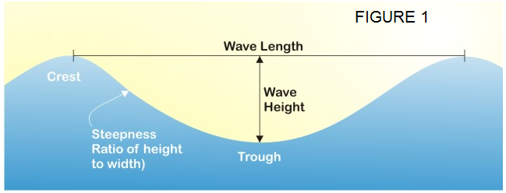

Figure 1- visual explanation about the wave properties

Waves are generally generated by wind passing over the surface of the sea, but can also form via atmospheric pressure and gravitational attraction. Landslides and other Earth movements (tectonic movement) can also create waves, demonstrated with catastrophic effect by the Japanese Tsunami of 2011. The wind attempts to ‘stretch’ the surface of the sea by rubbing against the surface of the water. This causes water molecules on the surface to move in the same direction as the wind. The water molecules collide with each other and so start moving forward. It’s just basic friction. As long as the waves move forward slower than the wind speed just above the waves, energy moves from the wind to the waves. If the wind is continuous the wave period and height grow together. Low pressure behind wave also contributes to forward motion. The wave height is determined by wind speed, how long the wind has been blowing, the fetch (the distance over which the wind excites the waves) and by the depth and surface of the seafloor (which can focus or disperse the energy of the waves). A given wind speed has a matching practical limit over which time or distance will not produce larger waves. When this limit has been reached the sea is said to be “fully developed”.

Formulas

**The formulas that we used to calculate the wave power in one point**:[4]

For cells with **water depth higher than half** the wavelength, λ, then wave power in kW per meter of wave front length: P = 0.49 ${H_{m0}}^{2}$ $T_{e}\frac{kW}{m^{3}*s}$**. Such that $T_{e}=\frac{m_{-1}}{m_{0}}$

where m-1 is the Spectral moments[5] (-1,0) wave period [s] [6] (parameter name:VTM10), m0 Spectral moments (0,2) wave period [s] (parameter name:VTM02) and $H_{m0}$ is Significant wave height[7] (parameter name:VMH0). Significant wave height is given in meters (m), and the wave period in seconds (s), wave power has units of kilowatts (kW) per meter of wave front length.

Interpolation of all these parameters (VMH0,VTM10,VTM02[8]) was taken from MEDSEA_ANALYSIS_FORECAST_WAV_006_017 database[9].

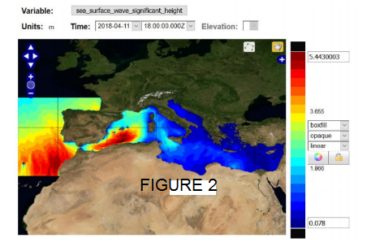

Figure presents example of interpolation of a parameter Significant wave height (VHM0) along the Mediterranean Sea. In the interpolation we can see the value of the Significant wave height at any point along the Mediterranean Sea. This figure was taken from MEDSEA_ANALYSIS_FORECAST_WAV_006_017 database [10]

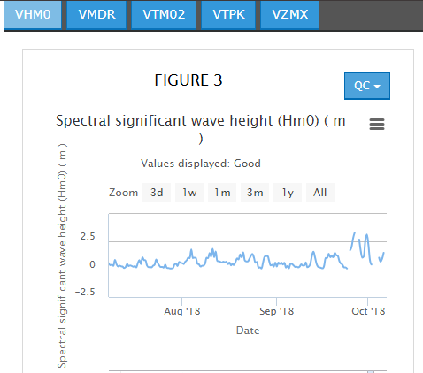

Figure 3 presents example of values of the parameter Significant wave height(VHM0)

over time at a specific point. The figure was taken from moon data-center[11].

**Figures 3,4 are examples of data we get from the databases we work with.**

Methods

**Calculating the formula over already existing interpolation**

The MEDSEA_ANALYSIS_FORECAST_WAV_006_017 database[12] presents an interpolation of all the variables (VTM10,VTM02,VHM0[13]) needed to calculate wave power along the Mediterranean Sea. We calculate wave power using the wave-power formula[14] on the interpolation results of these variables along the Mediterranean Sea.

**The process:**

1. Downloads all files of the interpolations from this address[15].

2. Calculates the wave power values at any point according to the formula.

3. Displayed the results on images.

In additions, we made a video[16] showing the change for an entire day and finally wrote some more meaningful insights.

**Fourier Transform**

**Background and assumption:**

Fourier transform can help us to find cyclicality (is the data approximately repeating itself) over time.

Fourier transform[17] of length n is described by the flowing n*n matrix A[i,j]= $e^{-\frac{2π*i*j}{n}}$

The inverse is ${A[i,j]}^{-1}$ = $e^{\frac{2π*i*j}{n}}$.

This describes the data as a sum of f[j][i]= $e^{\frac{2π*i*j}{n}}$ where f[j] is the j frequency.

Representation of the data as sum of frequencies can be used to find out if the data is approximately periodic. For more details on the method, look at Wikipedia Fourier_transform[18].

**The process:**

We choose one point each time. For each point, we choose an array of consecutive samples. Breaks the array to the sum of frequencies. Find if there is a frequency such that the size of the frequency is significantly greater than the other frequencies. If there is such a frequency, the array is approximately cyclic with cycle that repeat the same number of times as the frequency number. For more explanation about the terms size and frequency look at Wikipedia Fourier_transform.[19]

**Other insights on wave-power values as a function of time**

We examined whether we can extract other insights from wave-power behavior over time.

**The process:**

1. Select a few points from the database[20]

At each point we examined results for 3 years / year / 3 months / month / week / day and tried to answer the question: Is there a week/month that repeats itself in a period of one month / three months / one year / 3 years?

**Results:**

**Results over space**

In 28.9.18 we predicted the wave-power values in 2.10.18 along the MediterraneanSea. We did it by using a prediction for the values of the parameters(VTM10,VTM02,VHM0[21]) along the Mediterraneansea for 2.10.18. In addition, we compared the results of the prediction of wave-power that was made in 28.9.18 for 2.10.18 with the real results of wave-power and the results are indeed close. This prediction was taken from MEDSEA ANALYSIS FORECAST WAV 006_017 database[22].

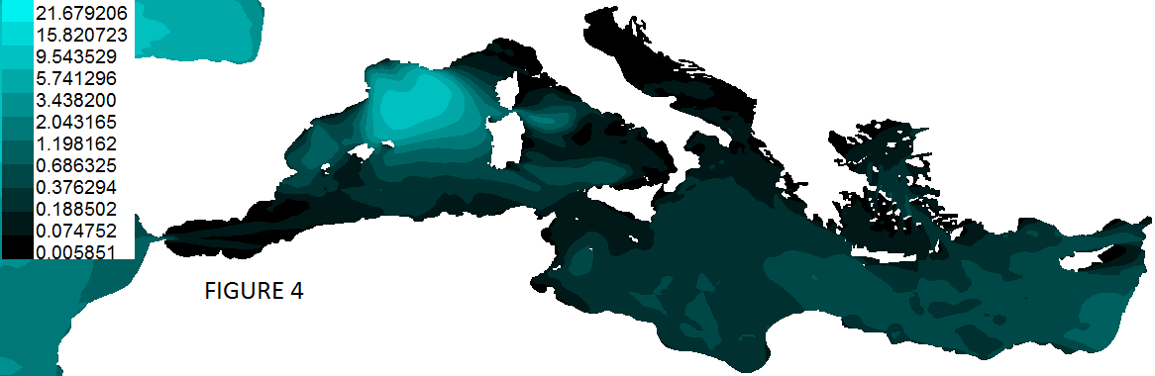

Figure 4- presents the results of a prediction that was made in 28.9.18 for 2.10.18. This data was taken from MEDSEA_ANALYSIS_FORECAST_WAV_006_017 database[23].

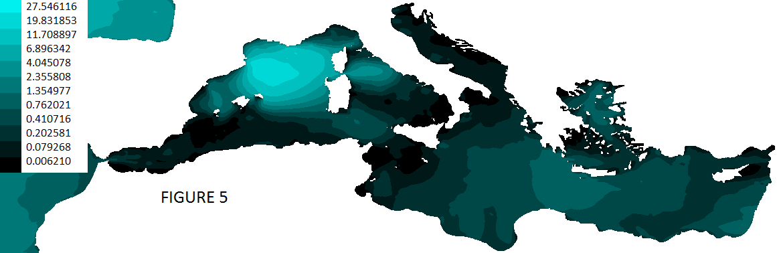

Figure 5- presents the interpolation of the wave-power values in 2.10.18 along the MediterraneanSea. This data was taken from MEDSEA_ANALYSIS_FORECAST_WAV_006_017 database[24].

**From figures 4, 5 you can see a comparison between the prediction and the real results. The two images similar.**

**Under the definition of the task area (**18.125° W to 36.2917° E and from 30.1875° N to

45.9792° S )**, it was observed that in Greece (**18.508° W to 27.2917° E and from 34.6875° N to

41.405° S)**, the results of wave-power were higher than in most other regions. For many tests. This data was taken from** MEDSEA_ANALYSIS_FORECAST_WAV_006_017 **database[25].**



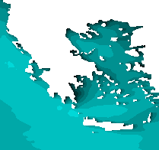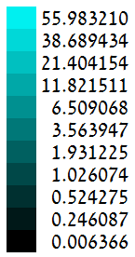

# Figure 6 presents an example of high values of wave-power in Greece area in 18.1.18. This data was taken from MEDSEA_ANALYSIS_FORECAST_WAV_006_017 database[26].

**Under the definition of the task area (**18.125° W to 36.2917° E and from 30.1875° N to

45.9792° S )**, it was observed that in the most eastern region of the Mediterranean (Israel, Turkey, Lebanon-**30.208° W to 36.2917° E and from 30.1875° N to

37.405° S**) the results of wave-power were lower than in most other regions. For many tests.**

**This data was taken from** MEDSEA_ANALYSIS_FORECAST_WAV_006_017 **database[27].**



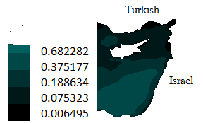

Figure 7 present example of low values of wave-power inmost eastern region of the Mediterranean in 2.12.17. This data was taken from this database[28]

**video results**

In the video[**https://drive.google.com/file/d/1YurVXVJP7uPJev0cEnPRlDYLzH2kvq1E/view**](https://drive.google.com/file/d/1YurVXVJP7uPJev0cEnPRlDYLzH2kvq1E/view)

we can see that the area with the high value of wave-power moves more or less in a straight line within 24 hours (18.1.18). Its start from Straits of Gibraltar and move to Israel. We estimated that the change over time may be affected by wind movement. This data was taken from MEDSEA_ANALYSIS_FORECAST_WAV_006_017 database.[29]

**Result over time**

**Results of Fourier Transform:**

We check the cyclicality(is the data approximately repeating itself) in few points separately**.** We found there is no cyclicality in any station.We did it on different sizes of arrays and we got similar results.

**Example of Fourier Transform on station 61227:**

We inserted the last 40 samples of the station 61227(latitude:35.5672, longtitude:25.1037) into the array and perform a version of Fourier Transform (with linear noise filter) on it.

**station 61227**

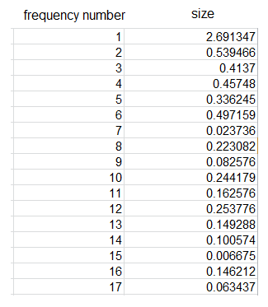



Figure 8 presents the results of Fourier Transform on a 40-measurements array that was taken from station 61227(latitude:35.5672, longtitude:25.1037). Size describes the energy of a frequency in the data and the frequency number describes the number times that the frequency repeats itself. More details about the parameters you can see in Wikipedia-Fourier Transform[30]. We see that there is no frequency such that the size is significantly bigger than the other frequencies .This means there is no cyclicality in the last 40 samples. This data was taken from INSITU_MED_NRT_OBSERVATIONS_013_035 database[31].

**Other insights on wave-power values as a function of time:**

In Fourier Transform results we have seen that regular cycles in arrays may not exist. After it we examined whether we can extract other insights from wave-power behavior over time. Below we have two tests, one for 360 (about three months) measurements and one for 1440 measurements (about a year). This data was taken from INSITU_MED_NRT_OBSERVATIONS_013_035 database.[32]

**Wave Power values as a function of Time (360 samples)**

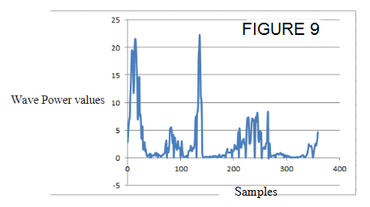

Figure 9 presents the wave power values as a function of timein the last 360 samples (3 months). You can see that there are weeks in which there is a sharp change relative to the weeks before

and after, but the rest of the time the intensity of increases and decreases is relatively low.

This data was taken from This data was taken from INSITU_MED_NRT OBSERVATIONS_013_035 database[33].

**Wave Power values as a function of Time (1440 samples)**

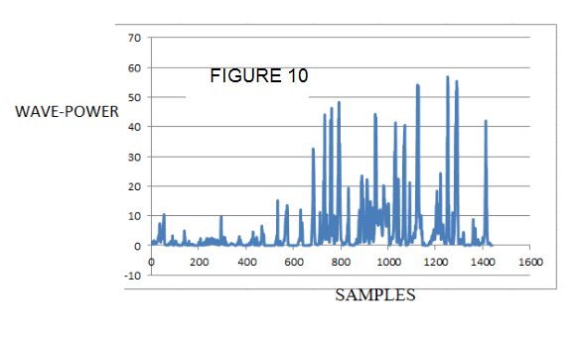

Figure 10 presents the wave power values as a function of time of one year. We can see that in approximately six months there are more or less relatively low values. But in the six other

months there are extreme changes in intensity in short periods of time. This data was taken

from INSITU_MED_NRT_OBSERVATIONS_013_035 database[34].

**Conclusion of Other insights on wave-power values as a function of time**

It can be seen that almost every year is divided into periods, such that there is a period in which there are a large number of high values relative to other periods (November - February), and a period with a large number of low values relative to other periods (April - June). In addition, there is a period in which there are a large number of values that are not too high and not too low relative to other periods (July-October).

Conclusion

We did not find cyclicality such that we can predict values for a long time. However, it is possible to estimate depending on the period in the year. In addition, you can see that the area with the high value moves more or less in a straight line over time. In addition, we tried to create a prediction system by plotting a Trinom through the data, but there were not enough measurement points to obtain anything useful. More details on the Trinom in Appendix 1.

Access to information was not clear enough. In addition, the use of netCDF files is not intuitive and requires in-depth study to read the files and understand what functions are useful. Also netCDF is not a uniform format and different files need different functions to translate the content.

Appendix 1

Trinom

The entire project is based on the assumption that there is a function that reflects the reality in the Mediterranean Sea and the function can be approximated by a trinom (a generalization of taylor series[35] approximation for 3 dimensions). Which means that if we know the function we can find at any point the value of the wave-power at this point. In fact, that's the prediction we're looking for. Taylor series[36] is a representation of a function as an infinite sum of terms that are calculated from the values of the function's derivatives at a single point. A function can be approximated by using a finite number of terms of its Taylor series. Taylor theorem gives quantitative estimates on the error introduced by the use of such an approximation. Taylor series are used for a function with one variable. A Taylor series for 3 variables are called “trinom”. We do not know the exact function we assumed in the area at sea, but we can approximate the trinom that represents it by plotting a trinom through several points with known values ​​(the measurement points).

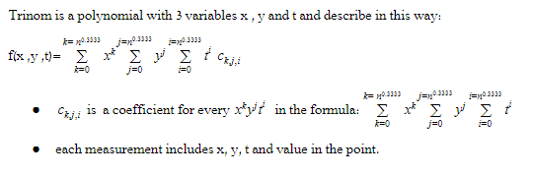

To get trinom from n points we use interpolation method.

**Algorithm of interpolation:**

1. Create f(x,y,t) a trinom with variable coefficients.
2. For every point (p.x,p.y,p.t,p.v) create a linear equation(p.x,p.y,p.t) = p.v

1. find solution for the set of linear equations in order to calculate f(x,y,t).

After we found the trinom, any point that we put in the trinom we will get the forecasting value in that point.

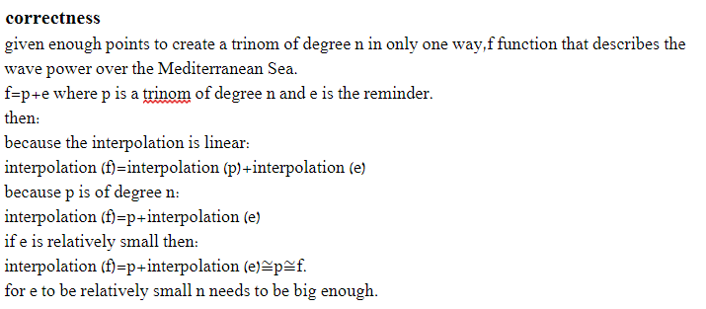

**Trinom in this project:**

In this project x and y describes coordinates , t describe time and value describe the value of wave-power.

**Method**

Further to what we have described above, the accuracy of the forecasting in a particular area depends on the degree of the trinom and the distribution of points in the area. On the Greece area there are much more points for trinom than in other areas along the Mediterranean Sea. Therefore, we focus in this area for forecasting the values of wave-power along Greece area and check if the number of points is sufficient for the trinom method.

We calculated trinom for each parameter (VMH0, VTPK[37]) along Greece area and then calculated for any point the value of wave-power by wave-power formula[38]. This data was taken from INSITU_MED_NRT OBSERVATIONS_013_035 database.[39]

In Greece area there are 6 sites that transmit information every few hours. The locations of the sites are fixed.

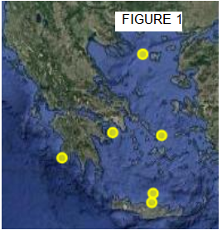

Figure 4 present the location of the sites in Greece costs. This picture was taken from 'mongoos'- data-center database.[40]

**Results:**

We calculated the wave power values along the Greece area using the trinom method. The wave-power values are not accurate. The difference between trinom results and interpolation results is too big The reason is that there are only enough points here for a trinom of degree[41] 2. Which means that the difference between the trinom and the realty (the remainder of a Taylor approximation) is too big.

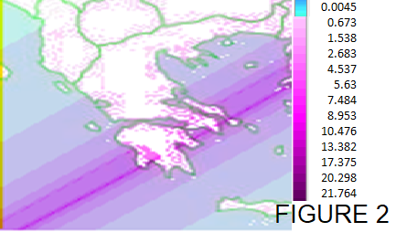

Figure 2 reflects the prediction of the wave-power values along the Greece area using trinom method in 27.12.17. This data was taken from INSITU_MED_NRT_

OBSERVATIONS_013_035.database.[42]

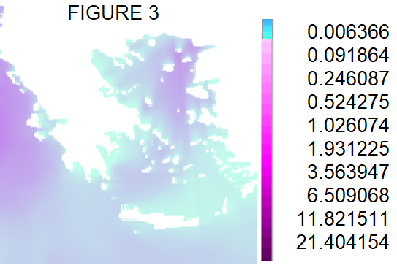

Figure 3 reflects the prediction of the wave-power values along Greece area using interpolation method in 27.12.17. This data was taken from MEDSEA_ANALYSIS FORECAST_WAV_006_017 database[43].

**From figures 2, 3 we can see the big different between the methods. As we see the interpolation method is closer to the real values. Therefore, trinom method is not an accurate method. As explained above, more measurement**  **points will increase the trinom degree and thus increase the accuracy of the trinom.**

Bibliography

<https://www.azocleantech.com/article.aspx?ArticleID=227>

G.P. Thomas. Wave Power: Theory Behind Ocean Waves. An explanation about the waves-power formulas and their uses.

<https://en.wikipedia.org/wiki/Significant_wave_height>

<https://en.wikipedia.org/wiki/Talk%3AWave_period>

<https://en.wikipedia.org/wiki/Moment_(mathematics)>

<https://en.wikipedia.org/wiki/Taylor_series>

<https://en.wikipedia.org/wiki/Interpolation>

<https://en.wikipedia.org/wiki/Fourier_transform>

References

* 1. <http://marine.copernicus.eu/services-portfolio/access-to-products/?option=com_csw&view=details&product_id=MEDSEA_ANALYSIS_FORECAST_WAV_006_017>
  2. <https://en.wikipedia.org/wiki/Significant_wave_height>,https://en.wikipedia.org/wiki/Talk%3AWave_period, <https://en.wikipedia.org/wiki/Moment_(mathematics)>
  3. <https://www.azocleantech.com/article.aspx?ArticleID=227>
  4. <https://www.azocleantech.com/article.aspx?ArticleID=227>
  5. <https://en.wikipedia.org/wiki/Moment_(mathematics)>
  6. s=second
  7. <https://en.wikipedia.org/wiki/Significant_wave_height>
  8. VTM10 is a name parameter of Spectral moments (-1,0) wave period [s], VTM02 is Spectral moments (0,2) wave period [s] and VMH0 is Significant wave height. These parameters were taken from this database.
  9. <http://marine.copernicus.eu/services-portfolio/access-to-products/?option=com_csw&view=details&product_id=MEDSEA_ANALYSIS_FORECAST_WAV_006_017> Choose interpolation over VMH0,VTM10, VTM02 parameters.
  10. <http://marine.copernicus.eu/services-portfolio/access-to-products/?option=com_csw&view=details&product_id=MEDSEA_ANALYSIS_FORECAST_WAV_006_017> Choose VHM0_interpolation.
  11. [http://www.mongoos.eu/data-center](%20http://www.mongoos.eu/data-center%20)  in this website click on station ATHOS and then click on wave tab.
  12. <ftp://nrt.cmems-du.eu/Core/MEDSEA_ANALYSIS_FORECAST_WAV_006_017/sv04-med-hcmr-wav-an-fc-h>
  13. VTM10 is a name parameter of Spectral moments (-1,0) wave period [s], VTM02 is Spectral moments (0,2) wave period [s] and VMH0 is Significant wave height. These parameters were taken from this database website <ftp://nrt.cmems-du.eu/Core/MEDSEA_ANALYSIS_FORECAST_WAV_006_017/sv04-med-hcmr-wav-an-fc-h>
  14. P = 0.49 **
  15. <ftp://nrt.cmems-du.eu/Core/MEDSEA_ANALYSIS_FORECAST_WAV_006_017/sv04-med-hcmr-wav-an-fc-h>
  16. [https://drive.google.com/file/d/1YurVXVJP7uPJev0cEnPRlDYLzH2kvq1E/view](%20https:/drive.google.com/file/d/1YurVXVJP7uPJev0cEnPRlDYLzH2kvq1E/view)
  17. <https://en.wikipedia.org/wiki/Fourier_transform>
  18. <https://en.wikipedia.org/wiki/Fourier_transform>
  19. <https://en.wikipedia.org/wiki/Fourier_transform>
  20. <ftp://nrt.cmems-du.eu/Core/INSITU_MED_NRT_OBSERVATIONS_013_035/history/mooring/> choose the relevant file
  21. VTM10 is a name parameter of Spectral moments (-1,0) wave period [s], VTM02 is Spectral moments (0,2) wave period [s] and VMH0 is Significant wave height. These parameters were taken from this database website <ftp://nrt.cmems-du.eu/Core/MEDSEA_ANALYSIS_FORECAST_WAV_006_017/sv04-med-hcmr-wav-an-fc-h>
  22. <ftp://nrt.cmems-du.eu/Core/MEDSEA_ANALYSIS_FORECAST_WAV_006_017/sv04-med-hcmr-wav-an-fc-h>choose the relevant file.
  23. <ftp://nrt.cmems-du.eu/Core/MEDSEA_ANALYSIS_FORECAST_WAV_006_017/sv04-med-hcmr-wav-an-fc-h>download **2.10.18_observation** file from this website.
  24. <ftp://nrt.cmems-du.eu/Core/MEDSEA_ANALYSIS_FORECAST_WAV_006_017/sv04-med-hcmr-wav-an-fc-h> download **new_2.10.18_observation** file from this website.
  25. <ftp://nrt.cmems-du.eu/Core/MEDSEA_ANALYSIS_FORECAST_WAV_006_017/sv04-med-hcmr-wav-an-fc-h> download 18.1.18_observation file from this website.
  26. <ftp://nrt.cmems-du.eu/Core/MEDSEA_ANALYSIS_FORECAST_WAV_006_017/sv04-med-hcmr-wav-an-fc-h> download 18.1.18_observation file from this website.
  27. <ftp://nrt.cmems-du.eu/Core/MEDSEA_ANALYSIS_FORECAST_WAV_006_017/sv04-med-hcmr-wav-an-fc-h> download 18.1.18_observation file from this website.
  28. <ftp://nrt.cmems-du.eu/Core/MEDSEA_ANALYSIS_FORECAST_WAV_006_017/sv04-med-hcmr-wav-an-fc-h> download 27.12.17_observation file from this website.
  29. <ftp://nrt.cmems-du.eu/Core/MEDSEA_ANALYSIS_FORECAST_WAV_006_017/sv04-med-hcmr-wav-an-fc-h> download 18.1.18_observation file from this website
  30. <https://en.wikipedia.org/wiki/Fourier_transform>
  31. <ftp://nrt.cmems-du.eu/Core/INSITU_MED_NRT_OBSERVATIONS_013_035/history/mooring/> download 61277_observation file from this website
  32. <ftp://nrt.cmems-du.eu/Core/INSITU_MED_NRT_OBSERVATIONS_013_035/history/mooring/> download 61277_observation ,ATHOS_observation,MIKON_observation files from this website
  33. <ftp://nrt.cmems-du.eu/Core/INSITU_MED_NRT_OBSERVATIONS_013_035/history/mooring/> download 61277_observation ,ATHOS_observation,MIKON_observation files from this website
  34. <ftp://nrt.cmems-du.eu/Core/INSITU_MED_NRT_OBSERVATIONS_013_035/history/mooring/> download 61277_observation,ATHOS_observation,MIKON_observation files from this website
  35. <https://en.wikipedia.org/wiki/Taylor_series> for more details
  36. <https://en.wikipedia.org/wiki/Taylor_series> for more details.
  37. VTPK is a name parameter of wave period [second] and VMH0 is Significant wave height(meter). These parameters were taken from this database
  38. <ftp://nrt.cmems-du.eu/Core/INSITU_MED_NRT_OBSERVATIONS_013_035/history/mooring/> download 61277_observation ,ATHOS_observation, MIKON_observation, SARON_observation, , 68422_observation, , HERLIKON_observation files from this website
  39. <http://www.mongoos.eu/data-center>
  40. <https://de.wikipedia.org/wiki/Polynom>
  41. <ftp://nrt.cmems-du.eu/Core/INSITU_MED_NRT_OBSERVATIONS_013_035/history/mooring/> download 61277_observation ,ATHOS_observation, MIKON_observation, SARON_observation, , 68422_observation, , HERLIKON_observation files from this website
  42. <ftp://nrt.cmems-du.eu/Core/MEDSEA_ANALYSIS_FORECAST_WAV_006_017/sv04-med-hcmr-wav-an-fc-h> download 27.12.17_observation file from this website

1. <http://marine.copernicus.eu/services-portfolio/access-to-products/?option=com_csw&view=details&product_id=MEDSEA_ANALYSIS_FORECAST_WAV_006_017>
2. <https://en.wikipedia.org/wiki/Significant_wave_height>,https://en.wikipedia.org/wiki/Talk%3AWave_period, <https://en.wikipedia.org/wiki/Moment_(mathematics)>
3. <https://www.azocleantech.com/article.aspx?ArticleID=227>
4. <https://www.azocleantech.com/article.aspx?ArticleID=227>
5. <https://en.wikipedia.org/wiki/Moment_(mathematics)>
6. S=second
7. [https://en.wikipedia.org/wiki/Significant_wave_height](https://en.wikipedia.org/wiki/Wave_height)
8. VTM10 is a name parameter of Spectral moments (-1,0) wave period [s], VTM02 is Spectral moments (0,2) wave period [s] and VMH0 is Significant wave height. These parameters were taken from this database
9. <http://marine.copernicus.eu/services-portfolio/access-to-products/?option=com_csw&view=details&product_id=MEDSEA_ANALYSIS_FORECAST_WAV_006_017>

   Choose interpolation over VMH0,VTM10, VTM02 parameters.
10. <http://marine.copernicus.eu/services-portfolio/access-to-products/?option=com_csw&view=details&product_id=MEDSEA_ANALYSIS_FORECAST_WAV_006_017>

    Choose VHM0_interpolation.
11. [http://www.mongoos.eu/data-center](%20%20http://www.mongoos.eu/data-center%20)  in this website click on station ATHOS and then click on wave tab.
12. <ftp://nrt.cmems-du.eu/Core/MEDSEA_ANALYSIS_FORECAST_WAV_006_017/sv04-med-hcmr-wav-an-fc-h>
13. VTM10 is a name parameter of Spectral moments (-1,0) wave period [s], VTM02 is Spectral moments (0,2) wave period [s] and VMH0 is Significant wave height. These parameters were taken from this database website <ftp://nrt.cmems-du.eu/Core/MEDSEA_ANALYSIS_FORECAST_WAV_006_017/sv04-med-hcmr-wav-an-fc-h>
14. P = 0.49 **
15. <ftp://nrt.cmems-du.eu/Core/MEDSEA_ANALYSIS_FORECAST_WAV_006_017/sv04-med-hcmr-wav-an-fc-h>
16. [https://drive.google.com/file/d/1YurVXVJP7uPJev0cEnPRlDYLzH2kvq1E/view](%20https:/drive.google.com/file/d/1YurVXVJP7uPJev0cEnPRlDYLzH2kvq1E/view)
17. <https://en.wikipedia.org/wiki/Fourier_transform>
18. <https://en.wikipedia.org/wiki/Fourier_transform>
19. <https://en.wikipedia.org/wiki/Fourier_transform>
20. <ftp://nrt.cmems-du.eu/Core/INSITU_MED_NRT_OBSERVATIONS_013_035/history/mooring/>

    choose the relevant file.
21. VTM10 is a name parameter of Spectral moments (-1,0) wave period [s], VTM02 is Spectral moments (0,2) wave period [s] and VMH0 is Significant wave height. These parameters were taken from this database website <ftp://nrt.cmems-du.eu/Core/MEDSEA_ANALYSIS_FORECAST_WAV_006_017/sv04-med-hcmr-wav-an-fc-h>
22. <ftp://nrt.cmems-du.eu/Core/MEDSEA_ANALYSIS_FORECAST_WAV_006_017/sv04-med-hcmr-wav-an-fc-h>choose the relevant file.
23. <ftp://nrt.cmems-du.eu/Core/MEDSEA_ANALYSIS_FORECAST_WAV_006_017/sv04-med-hcmr-wav-an-fc-h> download **2.10.18_observation** file from this website.
24. <ftp://nrt.cmems-du.eu/Core/MEDSEA_ANALYSIS_FORECAST_WAV_006_017/sv04-med-hcmr-wav-an-fc-h> download **new_2.10.18_observation** file from this website.
25. <ftp://nrt.cmems-du.eu/Core/MEDSEA_ANALYSIS_FORECAST_WAV_006_017/sv04-med-hcmr-wav-an-fc-h> download 18.1.18_observation file from this website.
26. <ftp://nrt.cmems-du.eu/Core/MEDSEA_ANALYSIS_FORECAST_WAV_006_017/sv04-med-hcmr-wav-an-fc-h> download 18.1.18_observation file from this website.
27. <ftp://nrt.cmems-du.eu/Core/MEDSEA_ANALYSIS_FORECAST_WAV_006_017/sv04-med-hcmr-wav-an-fc-h> download 18.1.18_observation file from this website.
28. <ftp://nrt.cmems-du.eu/Core/MEDSEA_ANALYSIS_FORECAST_WAV_006_017/sv04-med-hcmr-wav-an-fc-h> download 2.12.17_observation file from this website.
29. <ftp://nrt.cmems-du.eu/Core/MEDSEA_ANALYSIS_FORECAST_WAV_006_017/sv04-med-hcmr-wav-an-fc-h> download 18.1.18_observation file from this website.
30. <https://en.wikipedia.org/wiki/Fourier_transform>.
31. <ftp://nrt.cmems-du.eu/Core/INSITU_MED_NRT_OBSERVATIONS_013_035/history/mooring/> download 61277_observation file from this website.
32. <ftp://nrt.cmems-du.eu/Core/INSITU_MED_NRT_OBSERVATIONS_013_035/history/mooring/> download 61277_observation ,ATHOS_observation,MIKON_observation files from this website
33. <ftp://nrt.cmems-du.eu/Core/INSITU_MED_NRT_OBSERVATIONS_013_035/history/mooring/> download 61277_observation ,ATHOS_observation,MIKON_observation files from this website.
34. <ftp://nrt.cmems-du.eu/Core/INSITU_MED_NRT_OBSERVATIONS_013_035/history/mooring/> download 61277_observation,ATHOS_observation,MIKON_observation files from this website.
35. <https://en.wikipedia.org/wiki/Taylor_series> for more details.
36.
37. VTPK is a name parameter of wave period [second] and VMH0 is Significant wave height(meter). These parameters were taken from this database
38. .
39. <ftp://nrt.cmems-du.eu/Core/INSITU_MED_NRT_OBSERVATIONS_013_035/history/mooring/> download 61277_observation ,ATHOS_observation, MIKON_observation, SARON_observation, , 68422_observation, , HERLIKON_observation files from this website.
40. <http://www.mongoos.eu/data-center>
41. <https://de.wikipedia.org/wiki/Polynom>
42. <ftp://nrt.cmems-du.eu/Core/INSITU_MED_NRT_OBSERVATIONS_013_035/history/mooring/> download 61277_observation ,ATHOS_observation, MIKON_observation, SARON_observation, , 68422_observation, , HERLIKON_observation files from this website.
43. <ftp://nrt.cmems-du.eu/Core/MEDSEA_ANALYSIS_FORECAST_WAV_006_017/sv04-med-hcmr-wav-an-fc-h> download 27.12.17_observation file from this website